PRACTICLE TEST

ELECTIVE MODULE -1

QUESTION:3

HARDWARE/SOFTWARE:

1. WINDOWS 10/11
2. GOOGLE CROME/MOJILA
3. IBM CLOUD ACCOUNT
4. INTERNET

CLOUDANT:

1.Log in ibm cloud and search cloudant in catalog.

2.Type cloudant in the Search bar and click to open it.

3.Select an offering and an environment.

4.Type an instance name. 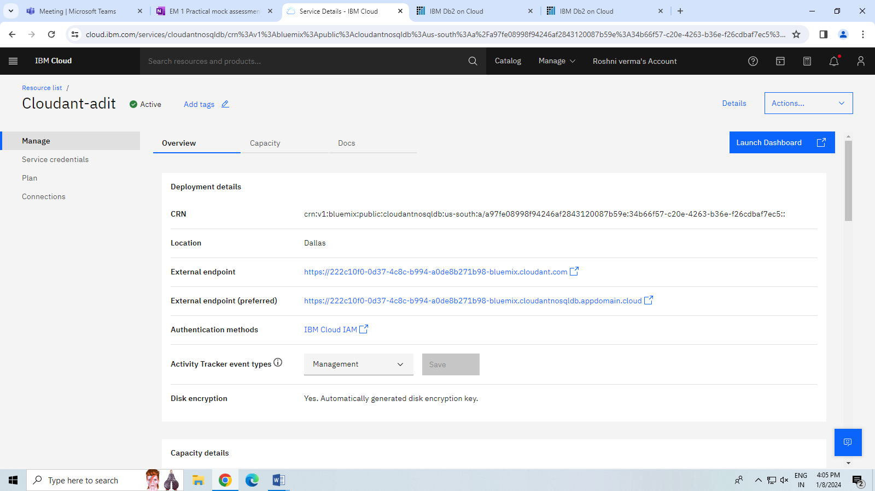

QUESTION-5 Invite users and add them in access groups using IAM in IBM Cloud

HARDWARE/SOFTWARE:

1. WINDOWS 10/11
2. GOOGLE CROME/MOJILA
3. IBM CLOUD ACCOUNT
4. INTERNET

STEP -1 Log in the ibm cloud and click on invite user.

STEP -2 Invite user lick then choose iam.

STEP -3 Another email are put and create.

STEP -4 Send and show successfully sended.

STEP -5 Then cheak on email.

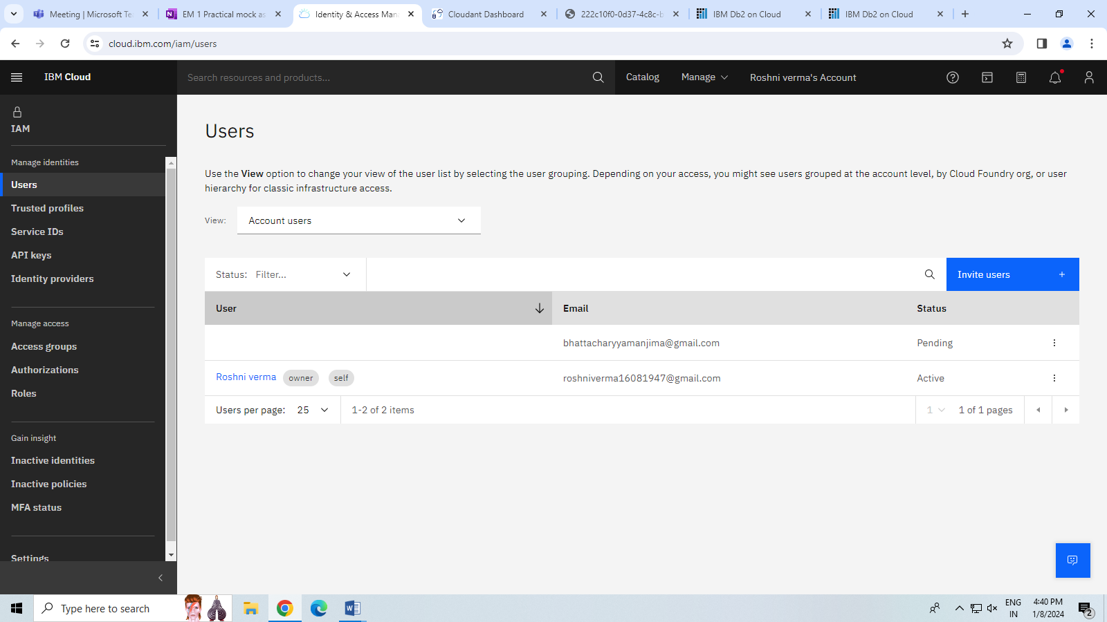

QUESTION -2 Creating a database & running SQL query on IBM db2. Load an external data(CSV) using db2.

HARDWARE/SOFTWARE:

1. WINDOWS 10/11
2. GOOGLE CROME/MOJILA
3. IBM CLOUD
4. INTERNET

STEP -1 LOG IN IBM CLOUD ACCOUNT

STEP -2 SEARCH DB2 IN CATALOG

STEP -3 CREATE A DATABASE NAME AND TABLE ARE CREATE

STEP -4 PUT ON CSV FILE IN DRAGE FILE

QUESTION -4 Customize your IBM Cloud Dashboard.

HARDWARE/SOFTWARE:

1. WINDOWS 10/11
2. GOOGLE CROME/MOJILA
3. IBM CLOUD
4. INTERNET

STEP -1 LOG IN IBM CLOUD ACCOUND.

STEP -2

STEP -3

STEP -4

STEP -5